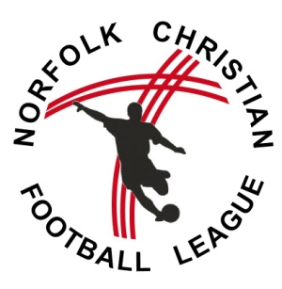
NCFL TEAM Affiliation Form: 2016/17 Season
FORM 2

A SEPARATE FORM NEEDS TO BE COMPLETED FOR EACH TEAM

We hereby seek affiliation to the Norfolk Christian Football League. We agree to abide by the rules and constitution of the League – in particular the Biblical Principles and Christian Ethics – and the decisions of the Management Committee.
PLEASE COMPLETE THE FORM CLEARLY AND IN BLOCK CAPITALS
Team Details: | 2016/17 details
Name of Club

Name of Team

Age division:
Team Colours:
(home and away)
Home Pitch: (including postcode)
Kick Off Time:

Dates unavailable
for fixtures
(e.g. school holidays)
Contact Details | Team Manager 2016/17
Name:
Address:
Landline Tel:
Mobile:
Email:
Church connection?
Please provide details of your church involvement
Team Manager Signature:
Club Secretary Signature:

- The final deadline for NCFL affiliation is Sunday 31st July 2016
- One form should be submitted for each team entered into the league
- Each form must include the signature of the Team Manager and the Club Secretary

The information supplied above is subject to the Data Protection Act 2000 and will be used by the League and the Norfolk County Football Association for administration purposes. Your contact details will be included in the NCFL handbook available only to NCFL clubs but please tick here [ ] if you DO NOT want your name and email address to be displayed on the website.

