Located in the countryside in East Anglia we are a small Community of women living a prayerful existence. Away from the hustle and the fast pace of the world outside, we share God’s work providing welcome, support and hospitality. Accommodation is offered in our two retreat houses; one in Ditchingham within the grounds of the Convent and one in Norwich adjacent to the Shrine of Julian. We welcome guests for any length of time, from one day up to a maximum stay of 10 days.

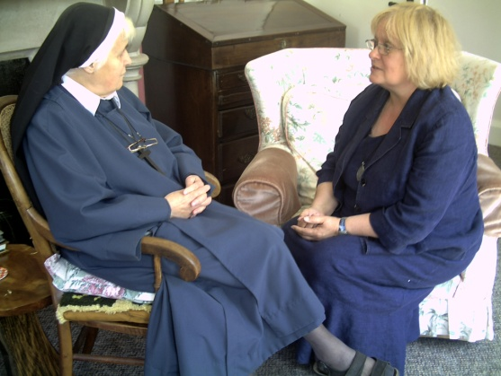
We understand that our guests come to stay for many different reasons. Some just need to get away for a little while... time to themselves for meditation, for respite, for reflection on life. Others are looking for more spiritual support and for closeness to God. They may join us for prayer and worship in chapel and enjoy time with us at lunch. The structure of your stay is entirely up to you.

Our 22 acre Ditchingham site is designed to support quiet reflection. Different habitats encourage and host an abundance of wildlife. Set in the countryside we experience very little traffic noise; only bird song, honey bees and the wind rustling the trees. When you have finished exploring our grounds there are many delightful walks in the surrounding countryside to discover. We can provide individually guided retreats and spiritual direction to guests in need of greater input during their stay. Or a less structured 'listening ear' can be made available to you should you wish. Please enquire about this at time of booking.
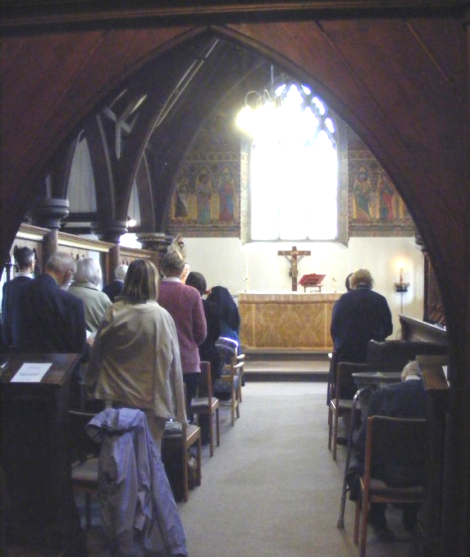
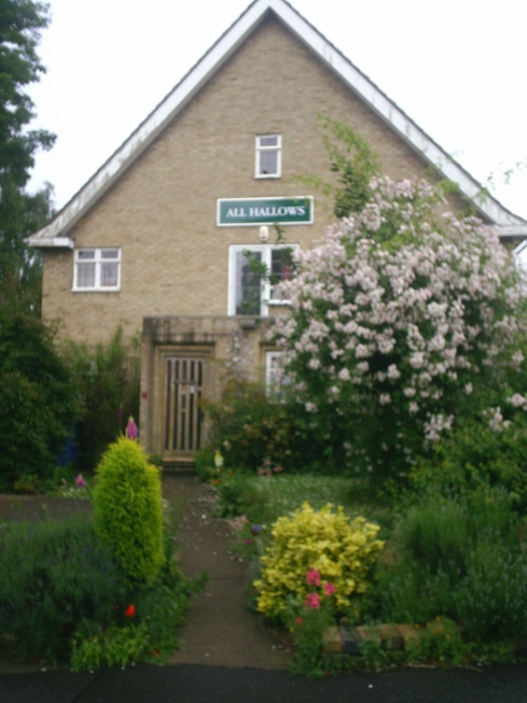
We regret we are unable to provide medical care for our guests. Visitors requiring support must bring an appropriate carer with them. We are also unable to cater for young families.

We organise and lead a programme of quiet days throughout the year. Details can be found on our website or by leaflet from the secretary.

Guests staying overnight will need to bring their own toiletries. Smoking is not permitted inside any building. All visitors are welcome to join the Sisters in Chapel for the Offices.
LAVINIA HOUSE, DITCHINGHAM

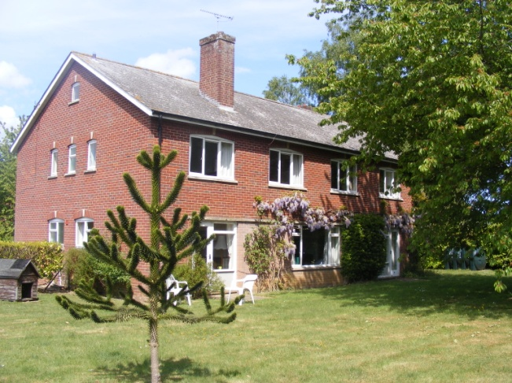
Lavinia House is located in the grounds of All Hallows Convent. The house has its own spacious garden, and is within easy reach of the Convent Chapel. It has two ground floor bedrooms and three single, one twin-bedded, and one double room on the first floor. Following a recent refurbishment all bedrooms are now en-suite. There is a shared kitchen, two airy sitting rooms, a pleasant dining room and a small prayer room for guest use. Food is provided at the house for the use of guests, who are asked to prepare their breakfast and supper at a time of their choosing. A cooked midday meal can be eaten with the Sisters in the St Michael's dining room.
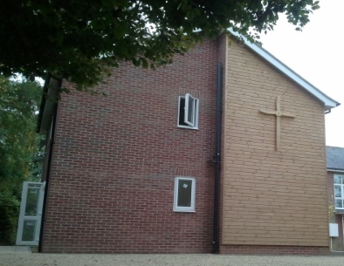
We are pleased and excited to announce the opening of a poustinia (indoor hermitage) within Lavinia House. This spacious first floor self-contained flat is available for those seeking complete solitude during their stay. There is no Wi-Fi available at Lavinia House, but guests are welcome to use the internet connection in the Rowan sitting room in St Michael’s House.

ALL HALLOWS HOUSE, NORWICH (Rouen Road)

All Hallows House, Norwich is an oasis in a busy city, providing space for those wishing for a time of study, quiet or private retreat and also for those visiting the Julian church or shrine. The house has three double and three single bedrooms, two sitting rooms, a dining room and a chapel. Wi-Fi is available.

A small pleasant garden at the back looks over the church garden and the shrine of Julian of Norwich. Next door, the Julian Centre houses an extensive spiritual library. There are also cards, books and other items for sale.

The house caters for visitors requiring bed, breakfast and an evening meal. To ensure the smooth running of the house, All Hallows will be closed from Wednesday evening until Friday mornings.
HOW TO BOOK

To make a booking please first contact the Guest Sister to check availability:

Lavinia House, Ditchingham 01986 892840
All Hallows House, Norwich 01603 624738
Email allhallowsconvent@btinternet.com

We request a £10 non refundable deposit to hold your booking.

COST

As a registered charity, the Community does not ask for a set fee to cover the cost of your stay, but invites donations to support our work. Guidelines below suggest contributions to cover our costs. While we do encourage our guests to make a realistic payment towards covering this, we know it is not always possible. We do not wish to preclude any who cannot afford these prices, and we hope that the generosity of those who can afford more will cover the shortfall of those who cannot.

Our current suggested donation is £37.00 - £40.00 per person per 24 hours on a full board basis. For self-catering accommodation we suggest £20.00 per night.

British Tax payers are invited to use Gift aid for their donations

HOW TO FIND US
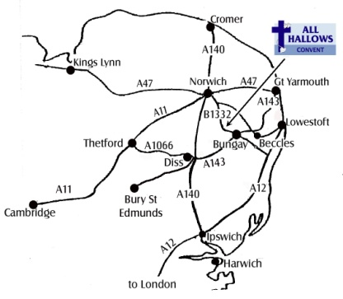
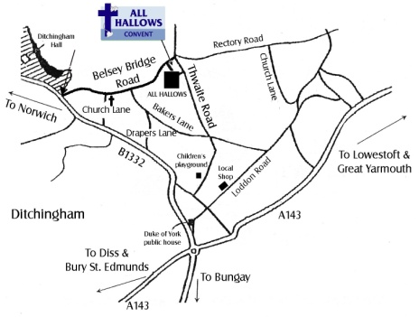

The Community of All Hallows is a Registered Charity no. 230143


Guesthouse accommodation
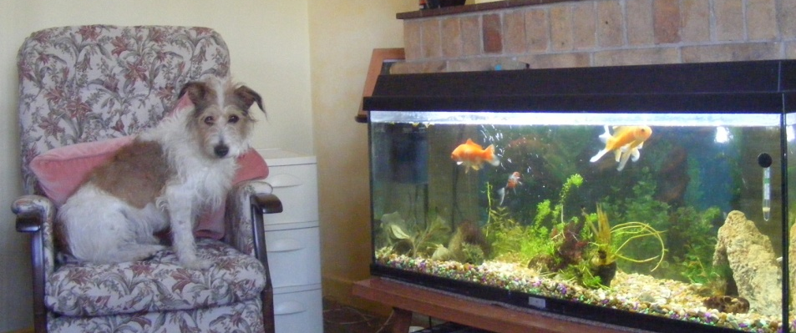

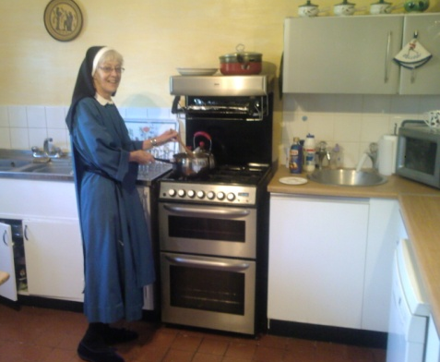
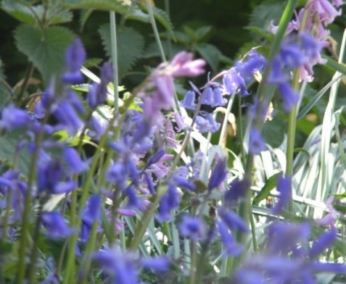

"Hospitality should have no other nature than love."
Henrietta Mears
All Hallows Convent,
Belsey Bridge Road, Ditchingham, Bungay, Suffolk, NR35 2DT

 01986 892749

allhallowsconvent@btinternet.com www.all-hallows.org



